Figure 1: Scatterplot of bwt (birthweight in grams) vs. lwt (mother’s weight in pounds)
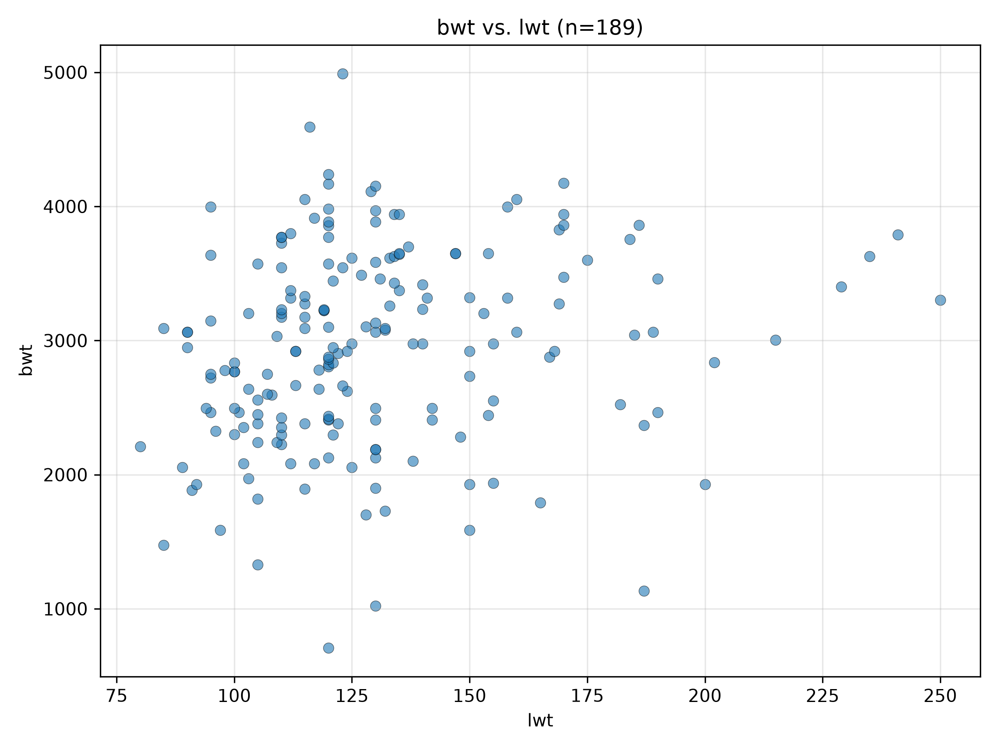

Figure 2: Scatterplot of bwt (birthweight in grams) vs. lwt (mother’s weight in pounds) with OLS regression line
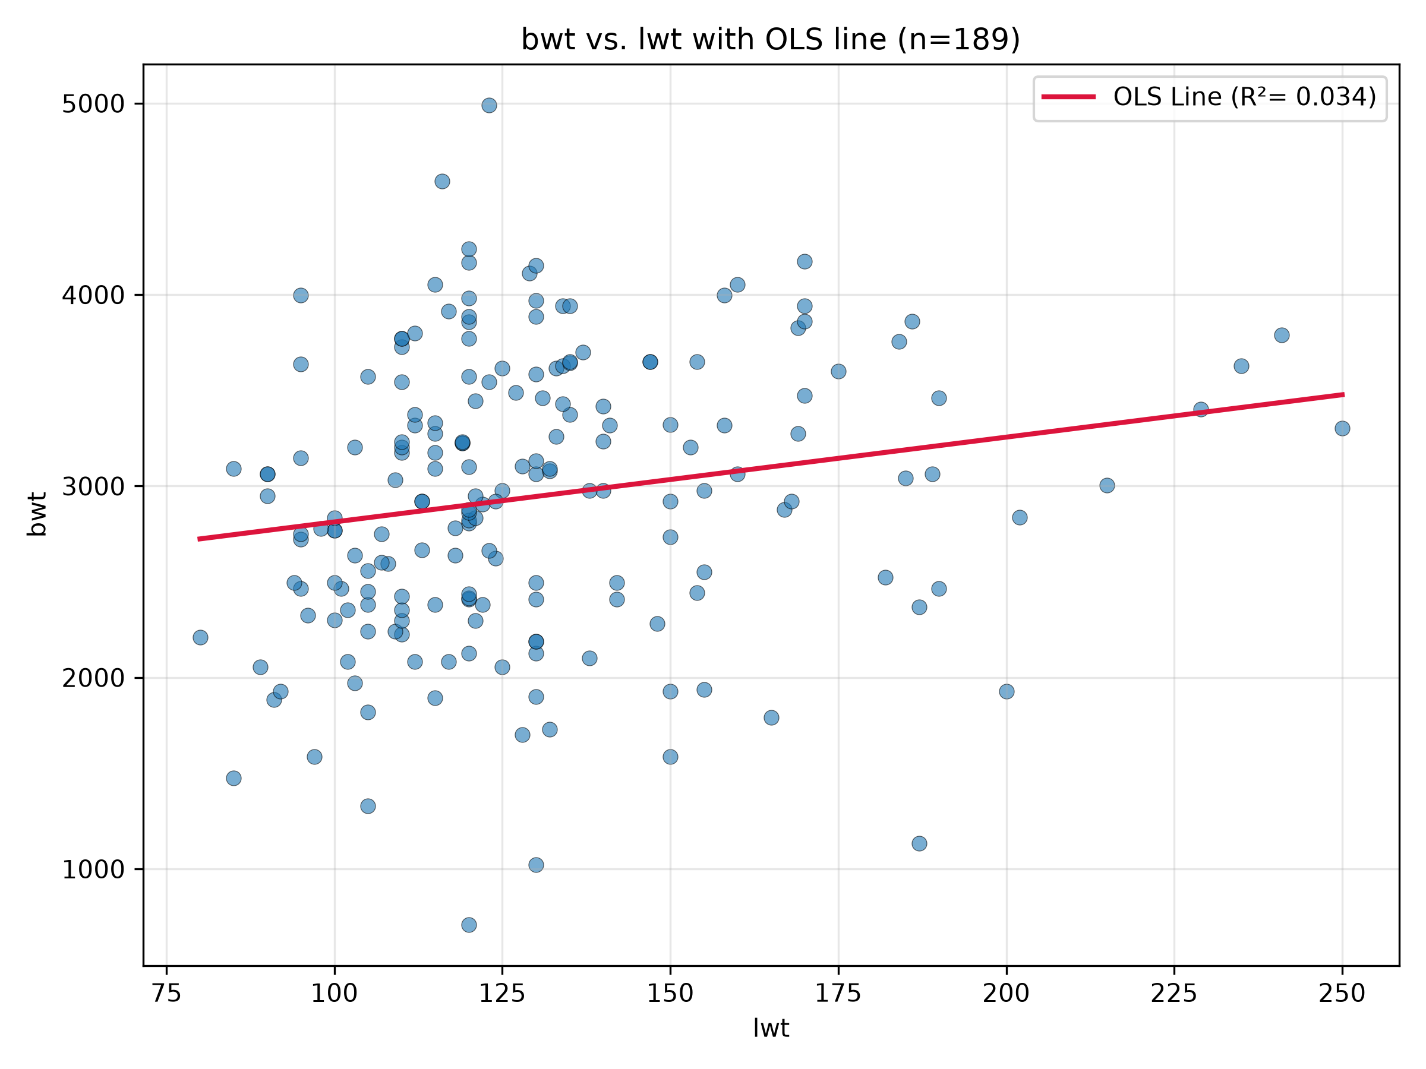
For Figure 1 & 2:
Independent Variable: Mother’s weight in pounds (lwt)
Dependent variable: Birthweight in grams (bwt)
$β_{o}$value (intercept): 2369.6235
$β_{1}$ value (slope coefficient): 4.4291
$R^{2}$ value: 0.034
Relationship between the variables: This scatterplot and regression line show that there is a weak positive relationship between the mother’s weight in pounds and birthweight in grams, with a projected increase of approximately 4.43 grams in birthweight for every 1-pound increase in mother’s weight

Figure 3: Scatterplot HOUSINSECU_CrudePrev (crude prevalence of housing insecurity) vs. TotalPopulation (total population)
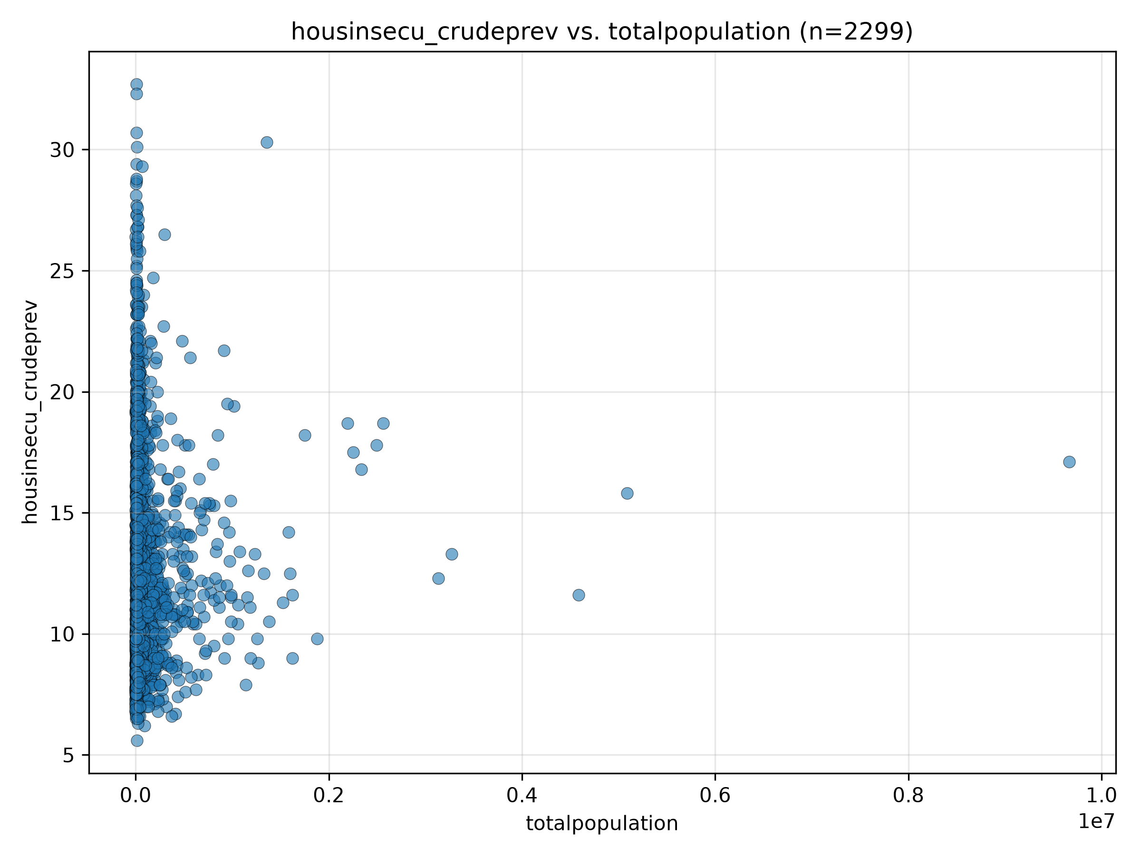

Figure 4: Scatterplot HOUSINSECU_CrudePrev (crude prevalence of housing insecurity) vs. TotalPopulation (total population) with OLS regression line
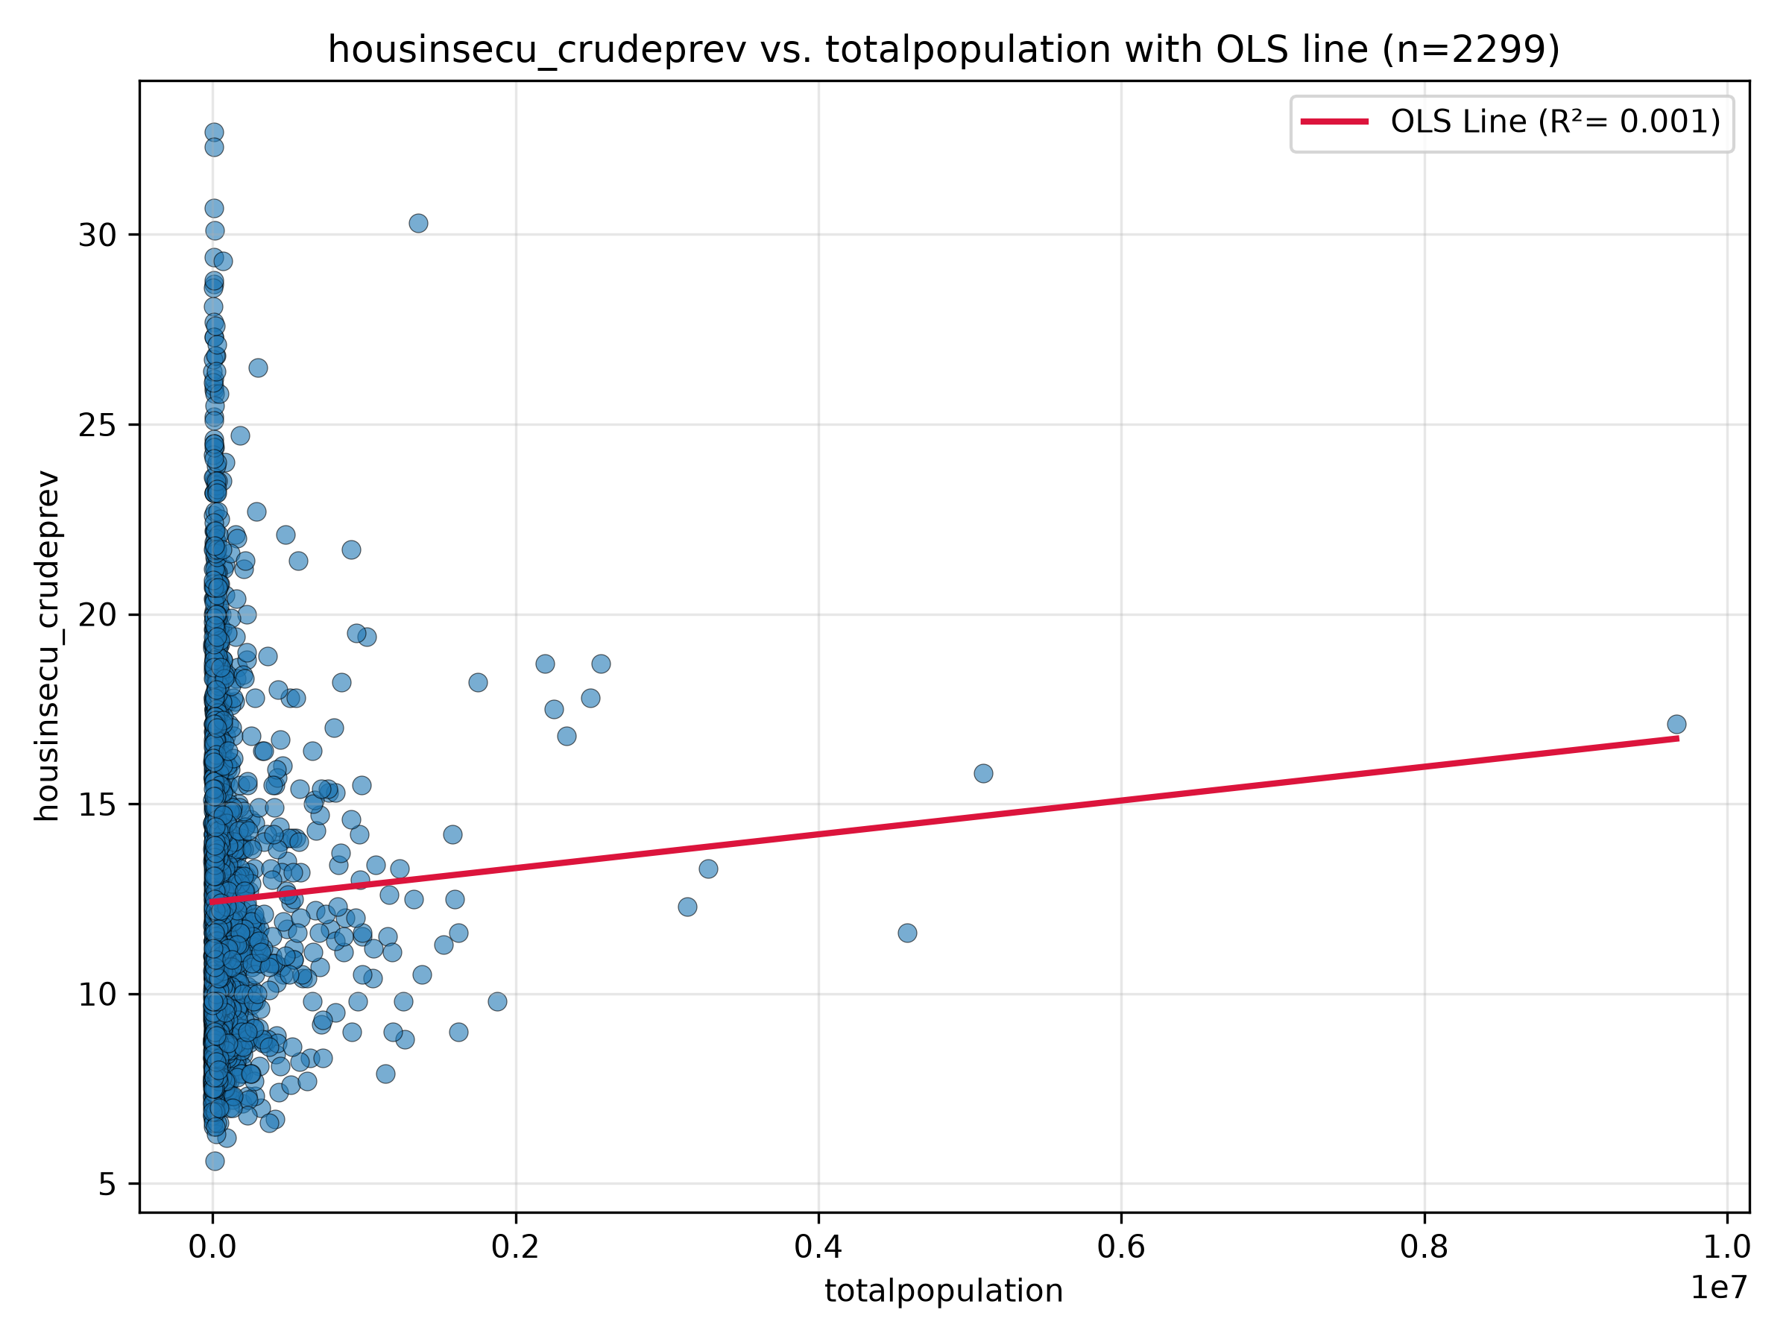
For Figure 3 & 4:
Independent Variable: Total population (totalpopulation)
Dependent variable: Crude prevalence of housing insecurity (housinsecu_crudeprev)
$β_{o}$value (intercept): 12.4181
$β_{1}$ value (slope coefficient): 4.45 x ${10}^{-7}$
$R^{2}$ value: 0.001
Relationship between variables: This scatterplot and regression line show that there is a very weak positive relationship between the total population and the crude prevalence of housing insecurity, with a projected increase of 0.000445 percentage points in the crude prevalence of housing insecurity for every 1000 additional people in the population.
Figure 5: Scatterplot of MHLTH_CrudePrev (crude prevalence of mental health disorders) vs. OBESITY_CrudePrev (crude prevalence of obesity)
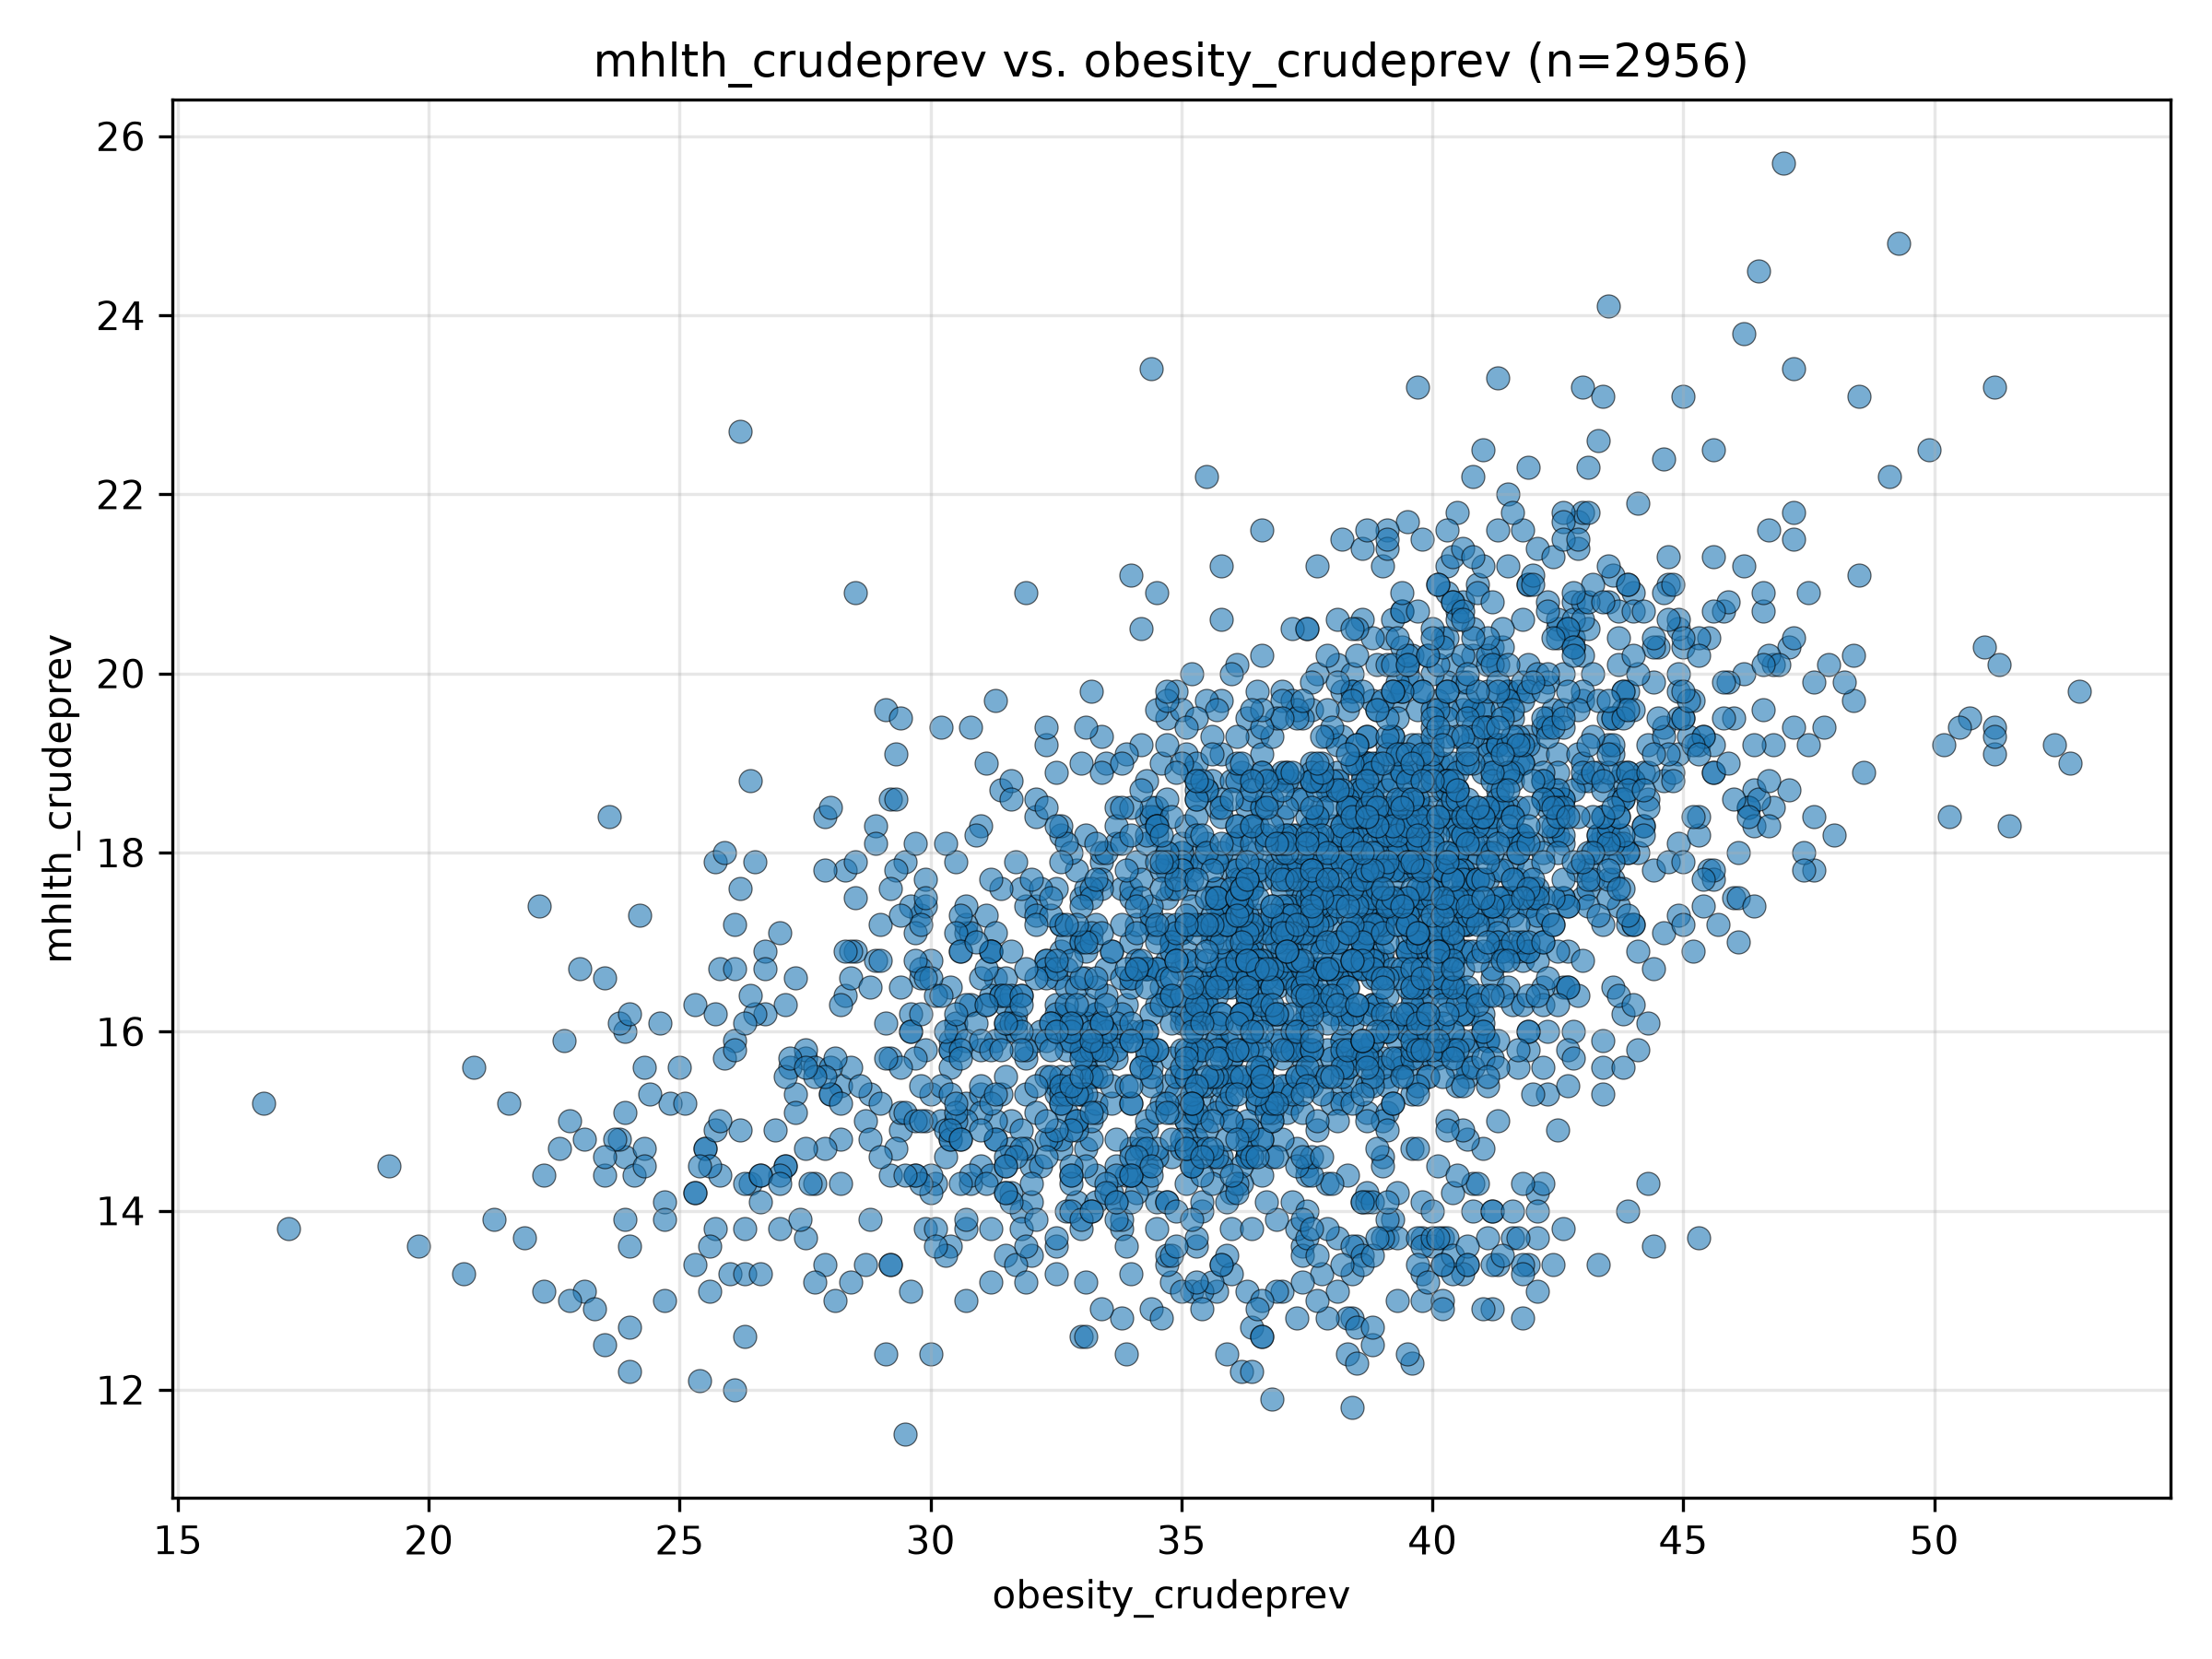

Figure 6: Scatterplot of MHLTH_CrudePrev (crude prevalence of mental health disorders) vs. OBESITY_CrudePrev (crude prevalence of obesity) with OLS regression line
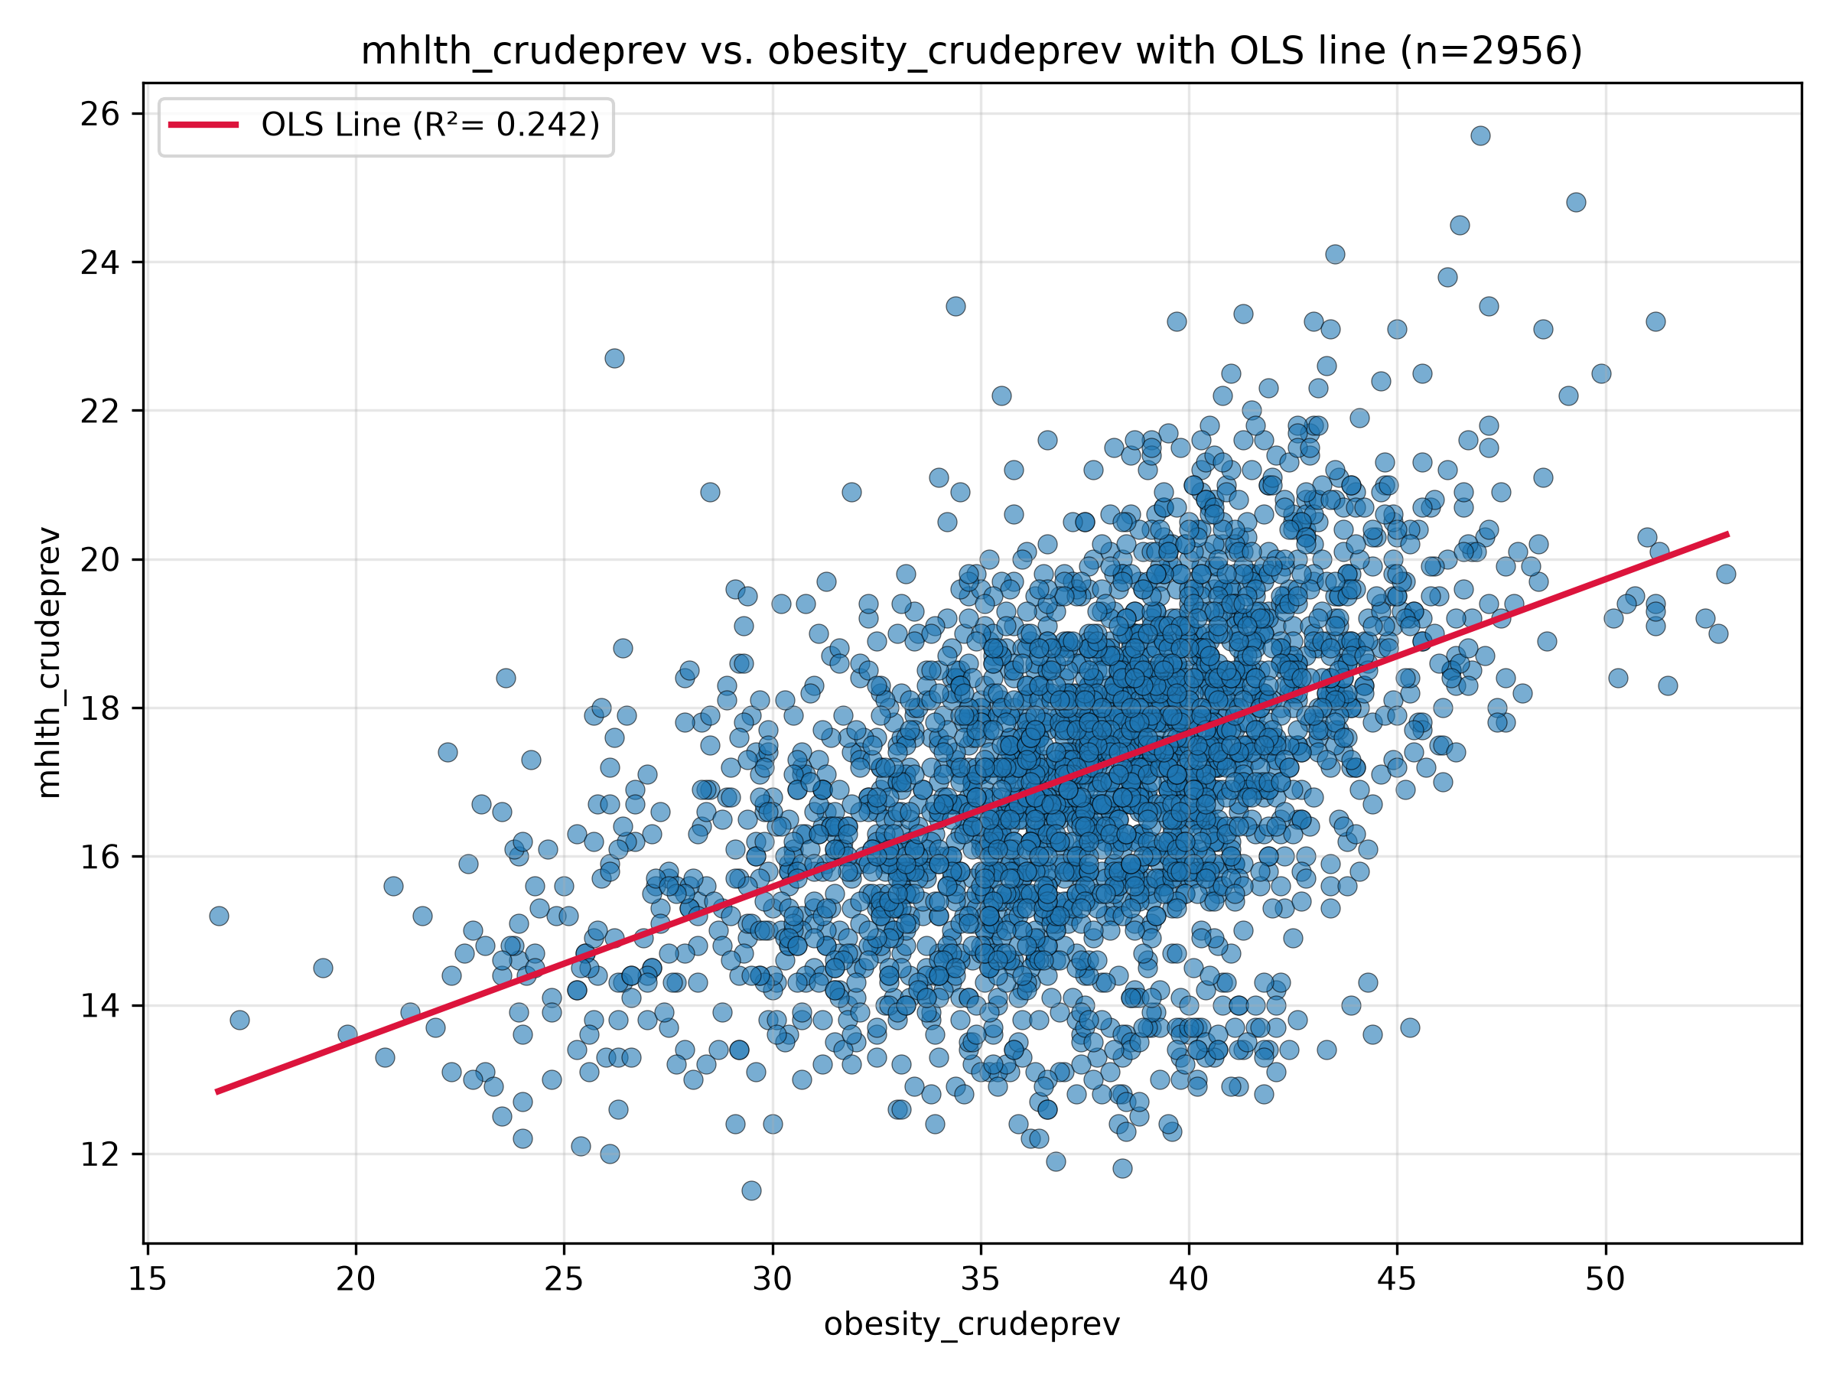
For Figure 5 & 6:
Independent Variable: Crude prevalence of obesity
Dependent variable: Crude prevalence of mental health disorders
$β_{o}$value (intercept): 9.3830
$β_{1}$ value (slope coefficient): 0.2069
$R^{2}$ value: 0.242
Relationship between variables: This scatterplot and regression line show that there is a moderate positive relationship between the crude prevalence of obesity and the crude prevalence of mental health disorders, with a projected increase of 0.2069 percentage points in mental health crude prevalence for every 1 percentage point increase in the crude prevalence of obesity

